**User Manual**

# Website Introduction:

## Captures:

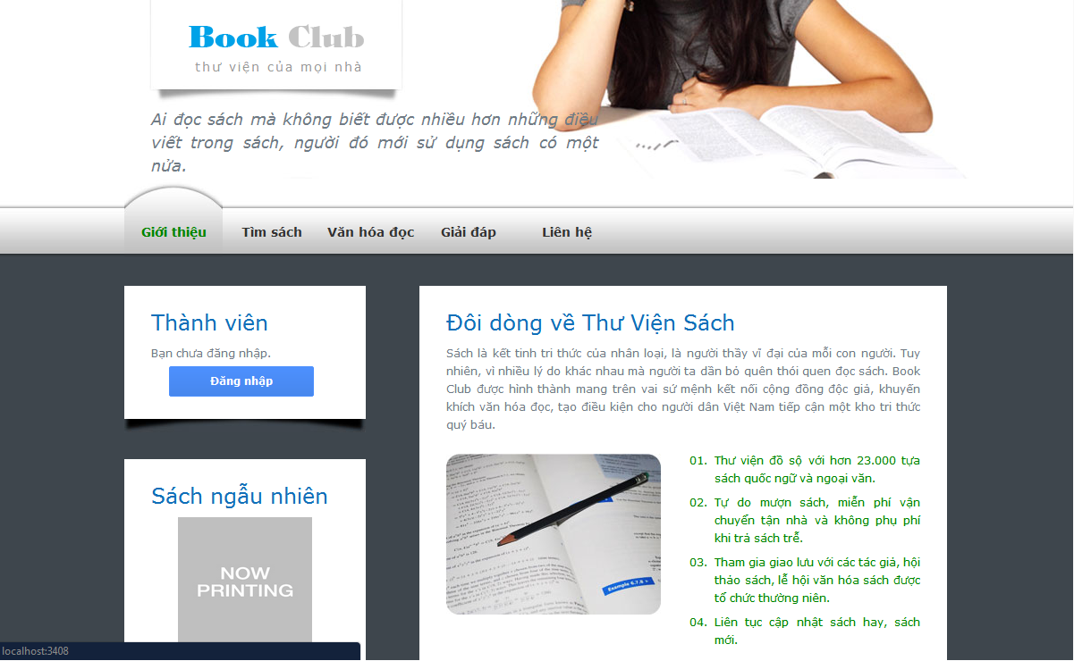

Image 1

## Introduction:

* This is the library's website. It helps bring books to the library closer to the readerand support the registration of books online.

# Login Function:

## Captures:

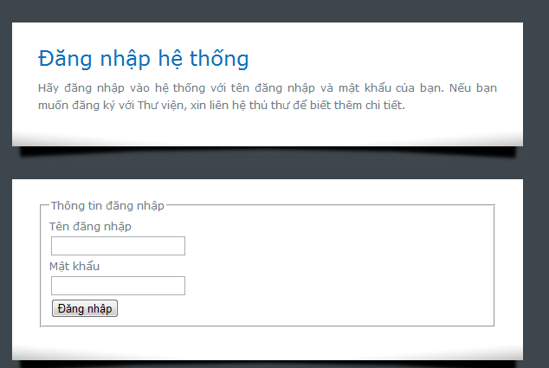

Image 2

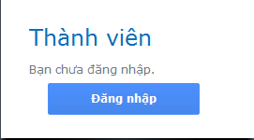

Image 3

## Step by step:

* If not signed, readers will still be able to find books and book information on this site. But to make the manipulation of the online register book, readers will needa library account and log into your account on this site.
* If not logged into the system, readers will see the text box as 'Image 3'.
* To login, users need to click at  to move to Login Page as you can see at ‘Image 2’.
* Field correct information of your account in the two text boxes. Then click at  to login.
* If the login is successful, in place of Image 3 readers will find: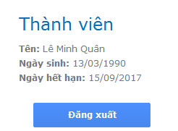

# Books Search:

## Captures:

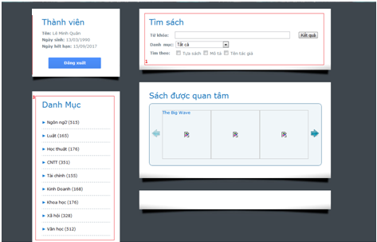

Image 4

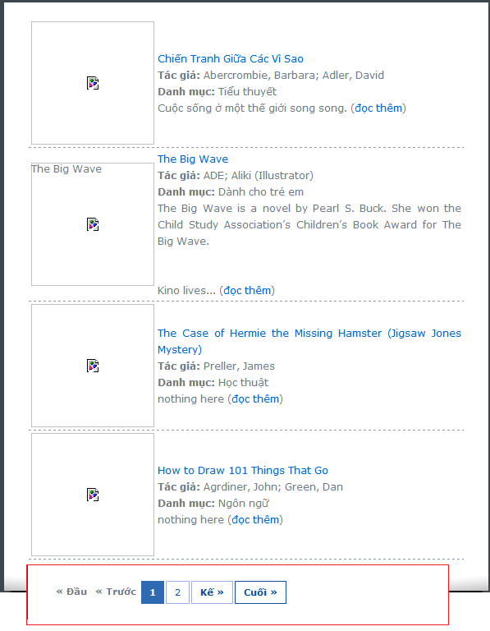

Image 5

## Notes:

* 1: This is the filter support readers find books they want.
* 2: In addition, users can select the list of books for each side.
* 3: If the result of over 10 books search, results will be split into multiple pages,each page contains 10 books.

## Step by step:

* To conduct a search of books, readers need to move from home to the tab"Search Book"
* The user will enter information into the  text box. .
* Then, readers can choose a category to which you want to search. If you select all, books in all categories will be looking for.
* At the check-box below, readers need to select at least one field to search for information accordingly. If not selected, the system will find all the books. 
* To start the search for books, readers can click button 
* Search results will be listed as 'Image 5'.

# Books Rental Register:

## Captures:

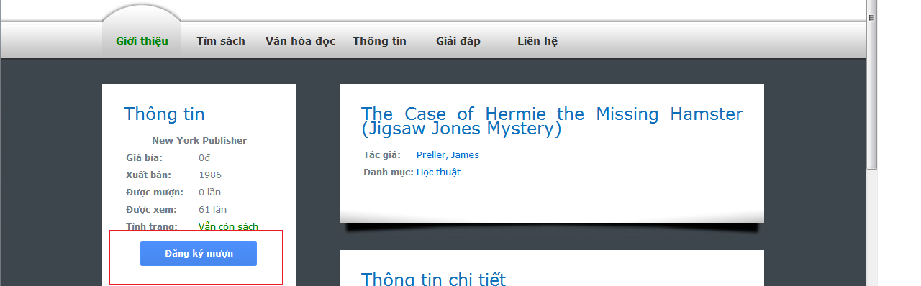

Image 6

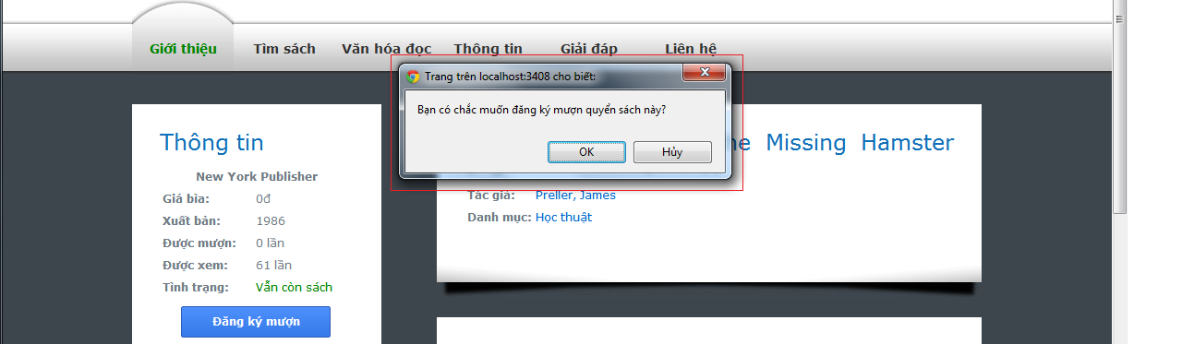

Image 7

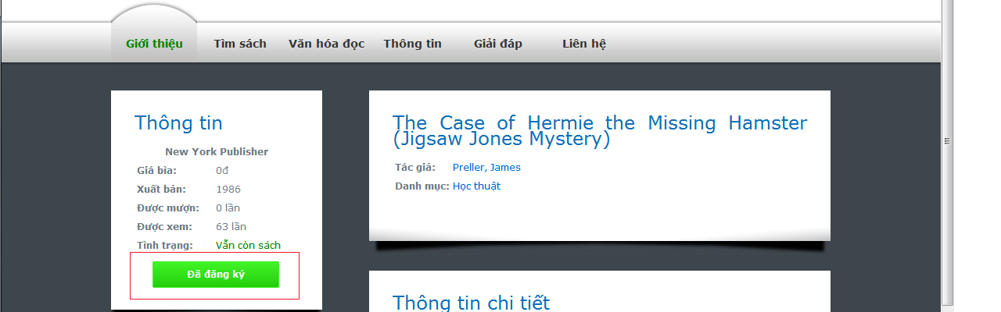

Image 8

## Step by step:

* After a successful login and find their desired books, readers will be able to conduct the registration of loan book.
* Click the titles you want to borrow to go to page book information.
* Readers need to pay attention on this line: . Because if this is the first condition "End", after registration, you will have to waitto get books about books.
* If the situation is the book "There are still books," readers click on the button  as ‘Image 6’.
* The system will need to confirm that readers want to borrow books as Image 7.  
  - If the reader to confirm that you want to borrow this book, they will see the button "Rental Register" transformed into: